OM621 Advanced Visual Analytics

Assignment 1
David Gibbs

- Who, What, How

- Who
I will be working with Stone Brewing Company at some point before 2025 since they stopped selling their products internationally this year and international business is more interesting for this scenario. My contact there is Jake Ratzke who is their Senior Supply Chain Manager and has been with the company since 2000.
- What
The issue the client has presented is a difficulty with budgeting, but I think that is a symptom of a larger problem that we can solve. I want the client to understand two things, that their process for arranging shipments is disorganized and that they have poor access to the data about the shipments they make. These are the two things that I think are causing difficulty with budgeting.
- How
I anticipate people will have a lot of questions about my presentation since it is recommending a major overhaul of their shipping process so an in person presentation seems best.
- How can I better get to know my audience?

To learn more about my audience I can research the company to find the reach of their logistics to better understand their needs. In this case they have multiple breweries in the US and also in Germany with each distributing to their surrounding areas.
Looking at LinkedIn I can see more about the key players including Arne Schildmeyer who is their international supply chain manager working out of Berlin and Brian Morrow who is the CFO and would likely be interested in getting more accurate transportation budgets and want to see the cost of this project.
If I can get access to their past budgeting information to see how much error there has been between their budgeted numbers and their actual spend I would be able to better understand the severity of the issue they are seeing.

- What is your data need for this case?

- Past transportation budgets vs. past actual transportation costs split by division to see what the issue looks like
- Past shipping information to see the total number of shipments and also see how they are distributed between different carriers split out by division.
- Past shipping costs per shipment to compare the current shipping cost structure to the proposed future costs to see if costs would be comparable or if there would be savings

- 3-minute story

As Stone has grown over time from a small local company to a large international business the need for efficiency has really grown with it. In the area of logistics this means there is a need to create a standard process for shipping that applies company-wide instead of allowing each division to manage their shipments ad hoc. This will reduce confusion, create economies of scale for freight costs, and make it easier to manage all the shipment data in one system.
By consolidating from using many carriers to having one primary carrier that can provide all the services needed you will be able to have one set of rules and paperwork for handling all shipments instead of having different ways of shipping with different carriers. This will also lead to having a uniform record of past shipments that can be used for forecasting future freight costs.
FedEx handles all types of shipments from small parcels to truck and container loads. They also provide access to shipping cost estimates before invoices are created through their online billing system and via their FedEx Developer Portal APIs. With all shipments going through them this would mean that all freight costs could be estimated and stored in a local database at the time of shipment instead of waiting weeks for the final invoices. This database would include final invoices and these estimates which would then serve and a basis for future budgeting and other analysis. FedEx also allows the use of subaccount numbers so that one number can be issued to each division to use. This will allow costs to be easily split out by division.
In the end this change would make the process of creating transportation cost budgets much easier and faster.

- Storyboard

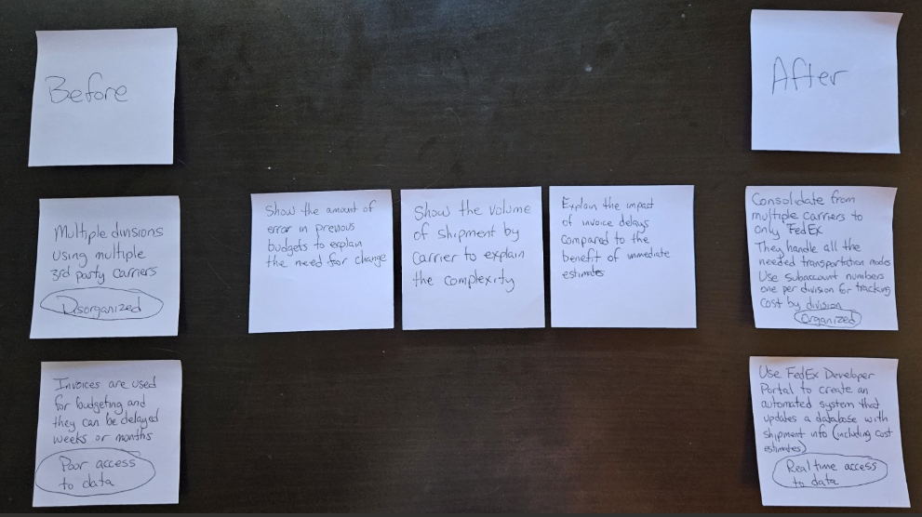

- What do you envision as a successful solution for this business problem?
I think by consolidating from using many carriers to using FedEx for all shipments and using subaccount numbers for each division this will overcome their first issue of disorganization. Costs will be able to be stored in a database with actual and estimated costs split out by division immediately, which eliminates the problem Stone was having with not being able to budget due to invoice delays. Even if the window of a few weeks before receiving the final invoices is being filled in with estimates I think that will be adequate for budgeting purposes.

